ECE 211/212

Team Project: Hand-Washing Smart Watch

Gabrielle Hladik, Jana AlHuneidi, Garth Crawford, Zheng Zhang

June 25th, 2020

**Introduction**

For our chosen project, we decided to pursue the idea of creating a watch that would include a reminder of when to wash your hands, as well as other features including how long to wash your hands for, and telling the time. We thought that this would be a great project during the COVID-19 pandemic since we know that the demand for proper health-care related upkeep is very necessary at these times. By giving notifications like this and providing a timer to allow for the recommended washing time, people will be more inclined to practice good hygiene techniques and keep their good health.

Other alternative projects we proposed are included below in our design matrix. We were able to narrow down our decision by analyzing these given elements: the cost of materials, the complexity of the project, the desirability of it to the user, the efficiency, and the practicality. Our final idea scored a 5 on the difficulty as the original design will be very simple, but as time goes on, we will propose additional features and functions to be added. In the design matrix below, we decided that 5 would indicate the least difficult and 1 would indicate the most difficult.

| DESIGN MATRIX | | | | | |  |
| --- | --- | --- | --- | --- | --- | --- |
| Design Decision | Design Elements | | | | | TOTAL |
|  | Difficulty | Cost | Desirability | Efficiency | Practical |  |
| **Gesture Controlled Robot** | 2 | 1 | 3 | 5 | 2 | 13 |
| **Pill Dispenser** | 3 | 2 | 5 | 5 | 5 | 20 |
| **Hand-Washing Reminder Watch** | 5 | 4 | 5 | 4 | 5 | 23 |
| **Automated Pet Feeder** | 4 | 3 | 5 | 4 | 5 | 21 |
| **Human Controlled Dino Game** | 3 | 3 | 2 | 3 | 5 | 16 |

**Project Requirements**

Our plan for this project is to create a basic watch with “smart” features that will help with hygiene techniques as well as send other reminders to the user, that will make their life easier and help to prevent the COVID-19 . Below is a list of our proposed requirements.

*L0 decomposition:*

For the design of the watch, we would have 3 inputs: the power, the switch input, and the vibration sensor. The output would be the LCD display that shows the time in either a 12 hour or 24 hour format, based on the preference of the user. The functions of the watch included telling the user the time, indicating how long the user should wash their hands for as well as when they should do so.

|  |
| --- |
| *Figure 1 - L0 Decomposition Blackbox of proposed watch* |

*Performance:*

Various smart watches offer various functions. Some wellness and fitness services, for example, tracking steps, platform for health applications, monitoring of sleep, tracking the rate of heartbeat among other sensor-related characteristics. Others offer varied mobile applications such as scheduling of events, showing notifications, answering phone calls, sending text messages, NFC payments, giving directions, and varying applications as well. Each smartwatch gives different features, feel and their look. People need to choose the smart watch that contains the features that they need.

*Functions:*

The project would be deemed successful if the watch is able to sense the movement of the user and initiate the 30 second countdown timer. In addition to this, the watch should be able to notify the user when they need to wash their hands. The watch shall potentially include the following functions:

* Shall set time to remind the user to wash the hand
* Shall have a clock function that displays the time on a 12-hour basis
* Shall have a timer that indicated to the user how long they must wash their wants for
* Shall be compact enough to be worn around the wrist
* May include the option of switching from a 12-hour clock to a 24-hour clock
* May have the ability to display the temperature in that given space, at that given time
* May possibly collect data of how often hands have been washed in a day; this would be done by transferring data to cloud or bluetooth or some other form so it could be seen on a device
* Shall be water resistant to some extent
* Shall have buzzers to remind the user needing to wash hands
* Shall have LED display status whether to wash hands

*Requirements/ Constraints*

* User friendly - Smart watches should largely depend on gestures rather than the navigation elements, should prioritize the significant, create tailored, stand alone content and support handoff. These devices have tiny targets. However, people have fat fingers and require bigger targets to touch input; bigger than the mouse. Smart watches offer convenience always as you can easily access information on your wrist. These devices are advantageous being with the user always as a result of a wrist watch factor which permits information access at the size of your wrist; this reduces the chances of misplacement. In the recent designs of smart watches, they are more effective power consumption. The enhanced power effectiveness has supported the union of services into a single gadget that are based on user context and sensory data. These services vary from the interface of the smartphone as they are tailored to specific backgrounds to resolve problems.
* Security - The influx of smart watches into the market has better its market leading to a million of them being sold. The manufacturers are enacting ways to link their products with the users. Security researchers progressively proceed to establish vulnerabilities on these gadgets. Out of the 10 brands tested, seven of them broadcasted firmware with no encryption; three of them had a blend of flaws and could permit harvesting of accounts. While these vulnerabilities may not contribute to a major breach to current privacy, the smart watches personalized nature will indicate that the individuals will depend on them more regularly in future tasks.
* Usability - There are numerous types of smart watches in the current markets, and the number of users is anticipated to rise. Each smart watch plays a unique role, and the quantity of information portrayed on their screens also increases. Nonetheless, the rather smaller screens are associated with some limitations; therefore it is hard to apply the used techniques to offer information on the available gadgets. The focus of this study is on the provision of menus on the touch screens of smart watches. And come up with a more efficient structure of the menu. An experiment was conducted where 40 items were given in a grid view layout. A given item was then searched by paging or scrolling down. The same procedure was repeated but this time using list view layout. From the findings, the grid view layout won more satisfaction in which the screen displayed many items but a shorter time to perform an operation. In another study, an effective menu structure was derived by displaying hierarchical stuff that could be categorized into lower and upper groups. Similarly, having many items on one screen was excellent when performing operations, time taken and effectiveness. Offering strength of menu by classification demonstrated acceptable outcomes in job achievement time, competence, and general contentment.
* Battery life - There are numerous types of smart watches in the current markets, and the number of users is anticipated to rise. Each smart watch plays a unique role, and the quantity of information portrayed on their screens also increases. Nonetheless, the rather smaller screens are associated with some limitations; therefore it is hard to apply the used techniques to offer information on the available gadgets. The focus of this study is on the provision of menus on the touch screens of the smart watches. And come up with a more efficient structure of the menu. An experiment was conducted where 40 items were given in a grid view layout. A given item was then searched by paging or scrolling down. The same procedure was repeated but this time using list view layout. From the findings, the grid view layout won more satisfaction in which the screen displayed many items but a shorter time to perform an operation. In another study, an effective menu structure was derived by displaying hierarchical stuff that could be categorized into lower and upper groups. Similarly, having many items on one screen was excellent when performing operations, time taken and effectiveness. Offering strength of menu by classification demonstrated acceptable outcomes in job achievement time, competence, and general contentment.

**Project Implementation**

*Project Timeline*

The figure below shows our gantt chart along with the tasks that we plan to accomplish within the next 8 weeks of this project.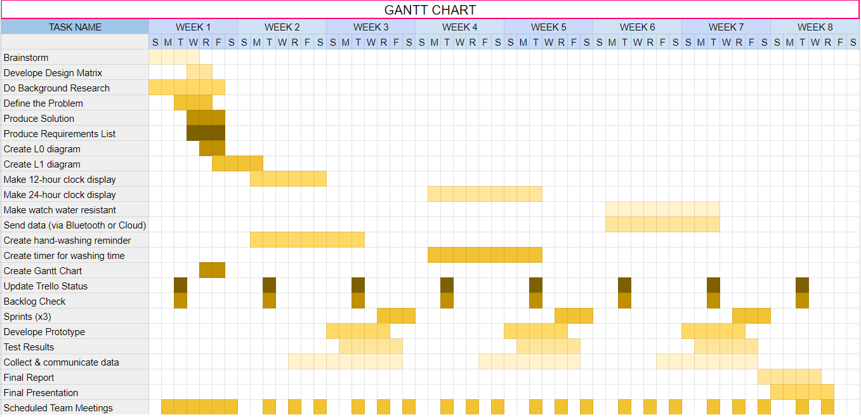

*List of Specialization*

* 3D Design and printing
* Soldering
* Programming by team members (to be assigned later)

*Primary List*

* Should notify user when it is time to wash their hands
* Should countdown the amount of time required to wash hands
* Should include the functions of a normal watch
* Should sense vibrations

*Sprint Description*

Sprint 1:

For sprint 1, we plan on creating a prototype watch that displays time on a 12-hour clock system, as well as notifying the user when it is time to wash their hands by using a buzzer for the alert.

Sprint 2:

For sprint 2, we plan on adding a 24-hour clock option to the prototype, as well as a sensor that will sense when the user begins to wash their hands and will begin a 30 second timer, indicating how long the user should wash their hands for. This will be indicated by an LED that will turn on for 20 seconds or blink 20 times for 1 second intervals.

Sprint 3:

For sprint 3, we plan to add bluetooth or the cloud to a device to collect the data,which will help us to analyze how often they are washing hands everyday and the efficiency they are. Besides, we also need to do some tests like testing battery capacity, ability of the timer and data collecting .

Summary

With this project, we plan on creating a smart-watch that has the ability to change from a 12-hour clock to a 24-hour clock display, as well as indicate when, and for how long the user should wash their hands for.. We also planned to make it possible for the data to be collected and transmitted via bluetooth or the cloud to a device so that the user would be able to track how often and how efficiently they were washing their hands each day. We decided to add on the hand-washing feature due to the current pandemic happening in the world. We realize that keeping good health and hygiene is of high importance at this time so we thought that this would be a great way to help people practice those habits

*All team members have contributed to this report, read it, and agree with its contents.*

**References**

DIY Hand Wash Reminder. (n.d.). Retrieved from <https://create.arduino.cc/projecthub/Mukesh_Sankhla/diy-hand-wash-reminder-3b2ceb?ref=platform&ref_id=424_trending__beginner_&offset=28>

GodsTale, & Instructables. (2017, October 17). Make Your Own Smart Watch. Retrieved from <https://www.instructables.com/id/Make-your-own-smart-watch/>

“When and How to Wash Your Hands.” *Centers for Disease Control and Prevention*, Centers for Disease Control and Prevention, 2 Apr. 2020, [www.cdc.gov/handwashing/when-how-handwashing.html](http://www.cdc.gov/handwashing/when-how-handwashing.html).